**S-98**



Published by the

International Hydrographic Organization

4b quai Antoine 1er

Principauté de Monaco

Tel: (377) 93.10.81.00

Fax: (377) 93.10.81.40

info@iho.int

www.iho.int

**Data Product Interoperability in S-100 Navigation Sytems**

**Part A: Level 1 Interoperability**

**Edition 1.0.0 – May 2022**

|  |
| --- |
| © Copyright International Hydrographic Organization 2022 |
| This work is copyright. Apart from any use permitted in accordance with the [Berne Convention for the Protection of Literary and Artistic Works](http://www.wipo.int/treaties/en/ip/berne/trtdocs_wo001.html) (1886), and except in the circumstances described below, no part may be translated, reproduced by any process, adapted, communicated or commercially exploited without prior written permission from the International Hydrographic Organization (IHO). Copyright in some of the material in this publication may be owned by another party and permission for the translation and/or reproduction of that material must be obtained from the owner. |
| This document or partial material from this document may be translated, reproduced or distributed for general information, on no more than a cost recovery basis. Copies may not be sold or distributed for profit or gain without prior written agreement of the IHO Secretariat and any other copyright holders. |
| In the event that this document or partial material from this document is reproduced, translated or distributed under the terms described above, the following statements are to be included: |
| *“Material from IHO publication [reference to extract: Title, Edition] is reproduced with the permission of the IHO Secretariat (Permission No ……./…) acting for the International Hydrographic Organization (IHO), which does not accept responsibility for the correctness of the material as reproduced: in case of doubt, the IHO’s authentic text shall prevail. The incorporation of material sourced from IHO shall not be construed as constituting an endorsement by IHO of this product.”* |
| *“This [document/publication] is a translation of IHO [document/publication] [name]. The IHO has not checked this translation and therefore takes no responsibility for its accuracy. In case of doubt the source version of [name] in [language] should be consulted.”*  The IHO Logo or other identifiers shall not be used in any derived product without prior written permission from the IHO Secretariat. |

Contents

A-1 Introduction 1

A-1.1 How to read this Part 1

A-2 Specification Scope for Part A 1

A-3 Data Content and Structure 2

A-3.1 Application Schema 2

A-3.1.1 Overview of Application Schema 2

A-3.1.2 Operations in pre-defined combinations 2

A-3.1.3 Enhanced selection of feature instances 2

A-3.1.4 Interoperability Levels 2

A-3.1.5 Hybridization rules 2

A-3.1.6 Hybrid Feature and Portrayal Catalogues 3

A-3.1.7 Progression of Interoperability Levels 3

A-3.2 Interoperability Catalogue 3

A-3.2.1 Conceptual types for Level 1 interoperability 3

A-3.2.2 Use of S-100 types 4

A-3.3 UML model documentation 4

A-4 Level-Specific Data Quality Considerations 5

A-4.1 Quality of displayed data 5

A-4.2 Quality of interoperability catalogues 5

A-4.2.1 Test methods 5

A-4.2.2 Data quality testing 5

A-5 Level-Specific Guidance on Making Product Specifications Interoperable 5

A-5.1 Duplicated features 5

A-5.1.1 Duplicated features same model 5

A-5.1.2 Duplicated features, different models 5

A-5.1.3 Duplicate feature domains 6

A-5.2 Geometry 6

A-5.2.1 Combined geometry 6

A-5.2.2 Spatial discrepancy, unrelated to scaled or cartographic smoothing 6

A-5.2.3 Spatial discrepancies, related to scale or cartographic smoothing 6

A-5.3 Display of text 6

A-5.4 Skin-of-the-earth feature operations 6

A-5.4.1 Skin-of-the earth feature replacement 6

A-5.4.2 Skin-of-the earth feature adjusting 6

A-5.5 Blended feature concepts 6

A-5.6 Hierarchy of data 6

A-5.6.1 Hierarchy by stacking of display planes 6

A-5.6.2 Predefined combinations 7

A-5.7 New datasets 7

A-5.8 Dataset scales, loading, and unloading 7

A-5.9 Metadata 7

A-5.10 Meta-features 7

A-5.11 Quality considerations 7

A-6 Portrayal 7

A-6.1 Display of significant features 7

A-6.2 Display of significant features - switching to original 8

A-6.3 Portrayal distinguishability - colour set-asides 8

A-6.4 Day/night/dusk modes 8

A-6.5 Impacts on viewing groups 8

A-6.6 Impacts on Portrayal Catalogues 8

A-6.7 Meta-features 8

A-6.8 Display of text 8

A-6.9 Skin-of-the-earth operations and portrayal 8

A-6.9.1 Skin-of-the-earth feature replacement and portrayal 8

A-6.9.2 Skin-of-the-earth feature adjusting and portrayal 9

A-6.10 Blended portrayals 9

A-6.11 Hierarchy of data 9

A-6.11.1 Interacting gridded information 9

A-6.12 Pick Reports 9

A-7 Processing Model 9

A-8 Normative Implementation Guidance 11

A-9 Feature Catalogue 12

A-10 Portrayal Catalogue 12

**Document History**

Changes to this Specification are coordinated by the IHO S-100 Working Group. New editions will be made available via the IHO web site. Maintenance of the Specification shall conform to IHO Resolution 2/2007 (as amended).

|  |  |  |  |
| --- | --- | --- | --- |
| **Version Number** | **Date** | **Approved By** | **Purpose** |
| 0.1 | 31 Jul 2017 | EM, RM | First draft. |
| 0.2 | 12 Dec 2017 | RM, EM | Changes from interoperability workshop and TSM5. |
| 0.3 | 08 Jul 2018 | EM, RM | Edits from March 2018 review comments  Updates for conformance to S-100 Edition 4.0.0, ISO 19115-1, and 19115-3. Removed metadata items not used by S-98 from the metadata documentation tables. |
| 1.0.0 RC1 | 13 Mar 2019 | RM | Applied S-100 WG4 decisions; updated metadata to conform to final version of S-100 Edition 4.0.0. |
| 1.0.0 (Draft) | 21 Mar 2019 | JW | Editorial updates for HSSC. |
| 0.4 | Jan 2020 | RM | Revised after TSM7 decision to separate interoperability into an abstract specification (new S-100 Part) and implementation specification (S-98). |
| 1.0.0 | May 2022 | S-100WG | Submission to HSSC14 for approval. |
| 1.0.0 | May 2022 | HSSC | Initial published version for evaluation and testing. |

Page intentionally left blank

# Introduction

S-98 Part A contains information that applies to Interoperability Catalogues which use interoperability rules and operations of at most Level 1 interoperability.

Interoperability Catalogues conforming to this Part must comply with both the following components of S-98:

1. S-98 Main Specification, which describes requirements applying to all S-98 Interoperability Catalogues and S-98 Exchange Sets;
2. S-98 Part A (this Part), which defines the subset of the interoperability model and Catalogue encoding that are specific to Level 1 interoperability.

The hypothetical processing model for implementations is described in general terms in the “S-98 – Main” document and elaborated in clause A-A-7 of this Part.

In Level 1 processing, feature types from different products, including S-101, are interleaved as specified by display plane and drawing priority information contained in the Interoperability Catalogue. The ENC is still treated as the main product, but feature layers from other products may be interleaved with ENC feature layers to prevent ENC data from being obscured. There is no other interoperability-related processing of feature data at this level.

The output of interoperability processing is either the original feature data (processing option 1) or drawing instructions (processing option 2), accompanied by display plane and drawing priority information, which is passed through to the portrayal processor. Clause A-7 elaborates on these options.

## How to read this Part

Clause A-2 of this Part contains scope identification information corresponding to the contents of this Part, which applies specifically to Interoperability Catalogues designated as Level 1.

For clauses A-3–A-10, the content of the clause or sub-clause extends or elaborates on the content under the same or similar clause heading or sub-heading in the S-98 – Main document.

The numbering of clauses A-3–A-10 may differ from that of corresponding clauses in S-98 – Main, because for some there is no additional Level-specific information needed. If a clause or sub-clause in S-98 – Main has no corresponding clause or sub-clause in this Part, there is no Level-specific information on that topic.

# Specification Scope for Part A

S-98 Part A describes the portions of S-98 which correspond to the following scope defined in S-98 – Main (clause 2):

**Scope Identification:** S98L1

**Level**: MD_ScopeCode – 13 (software)

**Level Name**: Interoperability Level 1

**Description**: Interleaving of feature types

**Extent**: EX_Extent.description = “worldwide”; EX_GeographicBoundingBox = [-180, +180, -90, +90]

# Data Content and Structure

## Application Schema

### Overview of Application Schema

The Application Schema for Interoperability Level 1 is depicted in Figure A-3.1 below. This Application Schema is a subset of the full Application Schema in S-100 Part 16. It consists of the following components:

1. Catalogue header information.
2. Display plane ordering information.
3. Display plane content in the form of either features or drawing instructions.

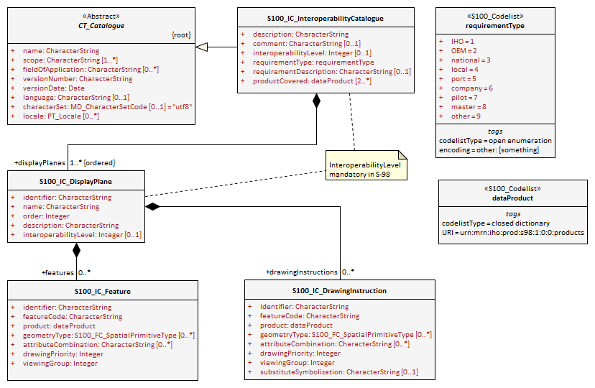

Figure A-3.1 – Level 1 Interoperability Catalogue

### Operations in pre-defined combinations

Operations in predefined combinations are possible only in Levels 2, 3, and 4 (Parts B, C, D).

### Enhanced selection of feature instances

Enhanced selection of feature instances is possible only in Levels 3 and 4 (Parts C and D).

### Interoperability Levels

The *interoperabilityLevel* attribute in **S100_IC_InteroperabilityCatalogue** specifies the highest level of interoperability implemented in that XML Interoperability Catalogue file. The *interoperabilityLevel* attribute in **S100_IC_DisplayPlane** specifies the level to which that display plane pertains.

### Hybridization rules

Hybridization rules are allowed only in Levels 3 and 4 (Parts C and D).

### Hybrid Feature and Portrayal Catalogues

Hybrid Feature and Portrayal Catalogues are allowed only in Levels 3 and 4 (Parts C and D).

### Progression of Interoperability Levels

The only progression of Interoperability Levels is from no interoperability (in which case Interoperability Catalogues are not involved and there is no interoperability Schema) to Level 1 interoperability.

## Interoperability Catalogue

### Conceptual types for Level 1 interoperability

The following clauses summarize the conceptual elements used in Level 1 Interoperability Catalogues. Details about these conceptual types are provided in S-100 Part 16.

#### Display plane (S100_IC_DisplayPlane)

A display plane element in the Interoperability Catalogue acts as a container for display information for specified feature classes, which enables the interleaving of feature layers during portrayal by indicating the display plane, priority, and drawing order of the features assigned to a display plane.

A feature type may be referenced in more than one **S100_IC_DisplayPlane**, but the entries in different display planes must be distinguished by different attribute-value combinations or spatial primitives so that the actual instances of features are partitioned unambiguously between different display planes.

The portrayal of feature types not mentioned in any **S100_IC_DisplayPlane** component is undefined until ordinary portrayal processing takes place.

#### Feature type display information (S100_IC_Feature)

The **S100_IC_Feature** element describes the display parameters for all features of a specific feature type in a specific product and thereby determines the order of drawing the feature type relative to other feature types in the same display plane. It also specifies the viewing group to which the feature is assigned. Its applicability can be optionally restricted to a subset of instances of the feature type by additional attributes that specify the type of spatial primitive and indicate specific values of thematic attributes.

#### Drawing instruction (S100_IC_DrawingInstruction)

Drawing instructions in the Interoperability Catalogue play a similar role to feature type display information (**S100_IC_FeatureType**) but with drawing instructions instead of feature objects. The **S100_IC_DrawingInstruction** element in Interoperability Catalogues is similar in operation to the layering and priority aspects of the **DrawingInstruction** element in Portrayal Catalogues (see S-100 Part 9 - Portrayal). Where there is a conflict with a Portrayal Catalogue drawing instruction, the drawing instruction in the Interoperability Catalogue supersedes the drawing instruction in the Portrayal Catalogue.

The **S100_IC_DrawingInstruction** element contains an additional attribute that allows substitution of symbolization instructions generated by portrayal processing.

##### Comparison and use of S100_IC_Feature and S100_IC_DrawingInstruction

**S100_IC_Feature** and **S100_IC_DrawingInstruction** elements in Interoperability Catalogues operate in essentially the same way as far as assignment of drawing order, priority, and display planes is concerned. They differ in that **S100_IC_DrawingInstruction** provides an optional attribute to substitute the symbolization elements of the drawing instruction.

**S100_IC_Feature** should be used for Interoperability Catalogues that are designed for systems where interoperability processing precedes the generation of drawing instructions.

**S100_IC_DrawingInstruction** should be used for Interoperability Catalogues that are designed for systems where interoperability processing precedes the generation of drawing instructions. It should also be used in all Catalogues where substitution of symbolization is necessary.

### Use of S-100 types

The S-100 types used by S-98 Level 1 Interoperability Catalogues are described in the S-98 – Main document. For Level 1 Interoperability Catalogues, the following additional information applies.

* Interoperability Catalogues of Level 1 do not use feature and information associations in feature filters.

## UML model documentation

The UML model documentation is provided in S-100 Part 16. This clause documents details specific to the use of the UML model for the interoperability Level described in this Part of S-98.

Only the model elements used in this Level (and included in the Level’s Application Schema) are listed. The constraints and considerations listed in the UML documentation tables in S-100 Part 16 apply. Any S-98 general or Level-specific considerations are described under the element name in the list below.

1. **S100_IC_DisplayPlane**: No Level-specific constraints or notes.

**Attribute** *interoperabilityLevel*: Mandatory in S-98 Catalogues at all levels. The only value allowed for Level 1 Interoperability Catalogues is 1.

1. **S100_IC_DrawingInstruction**:

NOTE for implementers: Even if the Presentation Schema in S-100 Part 9 is used, implementers may need to provide specific code to validate the content of the *substituteSymbolization* attribute instead of depending on normal XML Schema validation. The content of this attribute is not prescribed by this Specification and may be a fragment of XML, or interpretable code or rules, etc, in a non-XML syntax. It may be enclosed in a <![CDATA[ … ]]> section so that XML validators treat it as character data instead of XML.

1. **S100_IC_Feature**: No Level-specific constraints or notes.
2. **S100_IC_InteroperabilityCatalogue**:

**Attribute** *productCovered*: Must use values defined in the dictionary identified by MRN: urn:mrn:iho:prod:s98:1:0:0:products.

**Attribute** *interoperabilityLevel*: Mandatory. The only value allowed for level 1 Interoperability Catalogues is 1.

1. **Codelist dataProduct**: No Level-specific constraints or notes. The data type for all Levels is described below.

Codelist Type: closed dictionary

MRN: urn:mrn:iho:prod:s98:1:0:0:products.

1. **Codelist requirementType**: No Level-specific constraints or notes.

For all interoperability Levels, the following subset of the standard values listed in S-100 Part 16 are permitted to be used in S-98 Interoperability Catalogues:

Table A-3.1 - Allowed values for requirementType

|  |  |  |
| --- | --- | --- |
| **Value** | **Description** | **Code** |
| IHO | Original IHO Interoperability Catalogue | 1 |
| OEM | Prepared according to requirements specified by OEM or systems integrator | 2 |
| national | Prepared according to requirements specified by a national Government, group of national Governments (for example the European Union), or governmental agency such as a national shipping authority or the Coast Guard | 3 |
| local | Prepared according to requirements specified by a sub-national governmental authority such as a state, province, or county | 4 |
| port | Prepared according to requirements specified by a harbormaster's office or port authority | 5 |
| company | Prepared according to requirements specified by the owner, charterer, or operator | 6 |
| pilot | Prepared according to requirements specified by a pilot | 7 |
| master | Prepared according to requirements specified by the vessel’s master | 8 |

Extra values (“other: ...”) as defined in S-100 Part 3, clause 3-6.7 are also permitted.

# Level-Specific Data Quality Considerations

## Quality of displayed data

There are no Level-specific extensions to clause 6.1 of the “S98 – Main” document.

Clause A-A-5.111 provides guidance for maintaining data quality for Level-specific rules and operations.

## Quality of interoperability catalogues

The quality measures recommended in S-97 (Part C) which are applicable to Level 1 S-98 Interoperability Catalogues are those listed in Table 6-1 of the “S-98 – Main” document. There are no additional Level-specific measures for Level 1.

### Test methods

There are no Level-specific extensions to clause 6.2.1 of the “S-98 – Main” document.

### Data quality testing

There are no Level-specific extensions to clause 6.2.2 of the “S-98 – Main” document.

# Level-Specific Guidance on Making Product Specifications Interoperable

The guidelines in this clause supplement and extend guidance common to all Levels on making Product Specifications interoperable, which is given in clause 8 of the “S-98 – Main” document.

## Duplicated features

There is no Level-specific guidance for determining duplicated features. However, when Interoperability Catalogues are developed to resolve duplicated features, keep in mind the following Level-dependent considerations:

* Level 1 Interoperability Catalogues can allow only changes to the display planes and display orders specified in the products’ Portrayal Catalogues, as determined by display plane and drawing priority information. This means that features which are not covered by features with higher drawing priority or in an upper display plane will still be visible.

### Duplicated features same model

See the guidance in clause 8.1.1 of the “S-98 – Main” document.

### Duplicated features, different models

See the guidance in clause 8.1.2 of the “S-98 – Main” document.

### Duplicate feature domains

See the guidance in clause 8.1.3 of the “S-98 – Main” document.

## Geometry

### Combined geometry

Combined geometry is possible only in Interoperability Levels 3 and 4 (Parts C and D of this Specification).

### Spatial discrepancy, unrelated to scaled or cartographic smoothing

Resolution of this type of spatial discrepancy is possible only in Levels, 2, 3, and 4 (Parts B, C, and D of this Specification).

There is no Level-specific guidance for this issue. Common guidance is provided in clause 8.2.2 of the “S-98 – Main” document.

### Spatial discrepancies, related to scale or cartographic smoothing

Resolution of this type of spatial discrepancy is possible only in Levels, 2, 3, and 4 (Parts B, C, and D of this specification).

There is no level-specific guidance for this issue. Common guidance is provided in clause 8.2.3 of the “S-98 – Main” document.

## Display of text

There is no Level-specific guidance for this issue. Common guidance is provided in clause 10.8 of the “S-98 – Main” document.

## Skin-of-the-earth feature operations

### Skin-of-the earth feature replacement

Level 1 Interoperability Catalogues permit the following:

* Interleaving of display planes so that upper planes overwrite lower planes (Level 1 functionality). This can be used to shift feature layers to lower or higher planes to overwrite layers whose replacement is desired.

See clause A-6.9 for portrayal considerations.

### Skin-of-the earth feature adjusting

Adjustment of the geometry of skin-of-the-earth features is possible only in Level 4 (Part D).

## Blended feature concepts

Blended features or blended portrayal are only possible in interoperability Levels 3 and 4 (Parts C and D).

## Hierarchy of data

### Hierarchy by stacking of display planes

In Level 1 Interoperability Catalogues, hierarchy can be set only to the extent that display planes can be interleaved by the interoperability rules.

### Predefined combinations

Predefined combinations can be defined only in Level 2, 3, or 4 Interoperability Catalogues (Parts B, C, and D).

## New datasets

There is no Level-specific guidance for this issue. Common guidance is provided in clause 8.7 of the “S-98 – Main” document.

## Dataset scales, loading, and unloading

There is no Level-specific guidance for this issue. Common guidance is provided in clause 8.8 of the “S-98 – Main” document.

## Metadata

There is no Level-specific guidance for this issue. Common guidance is provided in clause 8.9 of the “S-98 – Main” document.

## Meta-features

Any spatial operations on meta-features require an Interoperability Catalogue to implement at least Level 4.

There is no other Level-specific guidance for meta-features. Common guidance is provided in clause 8.10 of the “S-98 – Main” document.

## Quality considerations

There is no Level-specific guidance for this issue. Common guidance is provided in clause 8.11 of the “S-98 – Main” document.

# Portrayal

This clause provides guidelines and instruction to portrayal considerations related to the use of the Interoperability Catalogue in an ECDIS. The Interoperability Catalogue must apply to the specific Product Specifications listed in the Interoperability Catalogue metadata, *interoperabilityCatalogueProducts* attribute under **S100_IC_CatalogueMetadata**.

There may be additional data products present in the S-100 ECDIS that are external to the Interoperability Catalogue; in such cases the Interoperability Catalogue should continue to function in the presence of products not defined in the Catalogue. Data products that are outside of the interoperability scope must be treated in Interoperability Level 0 (see clause 9.6 of the “S-98 – Main” document).

## Display of significant features

There is no Level-specific guidance for this issue. Common guidance is provided in clause 10.1 of the “S-98 – Main” document.

## Display of significant features - switching to original

There is no Level-specific guidance for this issue. Common guidance is provided in clause 10.2 of the “S-98 – Main” document.

## Portrayal distinguishability - colour set-asides

There is no Level-specific guidance for this issue. Common guidance is provided in clause 10.3 of the “S-98 – Main” document. See also S-100 Part 16 for specific guidance on colour set-asides.

## Day/night/dusk modes

There is no Level-specific guidance for this issue. Common guidance is provided in clause 10.4 of the “S-98 – Main” document.

## Impacts on viewing groups

There is no level-specific guidance for this issue. Common guidance is provided in clause 10.5 of the “S-98 – Main” document.

## Impacts on Portrayal Catalogues

There is no level-specific guidance for this issue. Common guidance is provided in clause 10.6 of the “S-98 – Main” document.

## Meta-features

There is no level-specific guidance for this issue. Common guidance is provided in clause 10.7 of the “S-98 – Main” document.

## Display of text

There is no level-specific guidance for this issue. Common guidance is provided in clause 10.8 of the “S-98 – Main” document.

## Skin-of-the-earth operations and portrayal

### Skin-of-the-earth feature replacement and portrayal

For all Levels, anything that replaces S-101 skin-of-the-earth features will overwrite it by having a higher priority; that is, be drawn later. The major difference between the Levels is in the overwriting.

Interoperability operations in Level 1 overwrite skin-of-the-earth features and everything else (by interleaving display planes so that upper planes overwrite lower planes).

Gridded data will generally go over ENC and obscure ENC features, either all (interoperability Level 0) or specific features (interoperability Level 1) depending on interoperability Level chosen, the predefined combinations or display plane of the features that are interacting.

EXAMPLE: High definition gridded bathymetry replaces (overwrites) depth area and depth contours, but soundings, aids to navigation, and obstructions are over the high definition bathymetry (interoperability Level 1).

NOTE: The safety contour comes from the ENC and is generated by the viewer system. This safety contour is an IMO requirement (IMO Performance Standard 5.8 (MSC.232(82))) for ECDIS and should be presented with highest priority when turned on by the user. OEMs are permitted to add additional safety contour functions; for example, generated from combining high definition gridded bathymetry (S-102) and S-104 input.

### Skin-of-the-earth feature adjusting and portrayal

This clause covers the possibility of the skin-of-the-earth feature geometry and/or attribute values being dynamically adjusted based on the corresponding features in other data layers.

Changes to the location or extent of symbols displayed on the screen due to a feature in another dataset are only possible in interoperability Levels 3 and 4 (Parts C and D).

## Blended portrayals

There is no Level-specific guidance for this issue. Common guidance is provided in clause 10.10 of the “S-98 – Main” document.

## Hierarchy of data

As noted in clause 11.11 of the “S-98 – Main” document, hierarchy of data can be controlled by predefined combinations (Level 2 and higher). Level 1 Catalogues offer only a very limited means of controlling hierarchy by means of display plane ordering. There is no Level-specific guidance for portrayal in connection with this issue.

### Interacting gridded information

There is no Level-specific guidance for portrayal in connection with this issue. Common guidance is provided in clause 10.11.1 of the “S-98 – Main” document.

## Pick Reports

*[NOTE: The Pick Report functionality specification in S-98 is still under development, and the content of this section will change as this functionality is defined.]*

Clause 10.12 of the “S-98 – Main” document applies. There is no additional Level-specific guidance for Level 1.

# Processing Model

Figures A-7.1 below shows the processing steps and input to each step from parts of the Interoperability Catalogue, for the “Interoperability before portrayal” processing option. Figure A-7.2 shows the steps and inputs for the “Interoperability after portrayal” processing option. In both cases, the flow depends on the interoperability Level selected by the mariner.

In Level 0 processing, interoperability is turned off and all data products loaded are passed through to S-100 Portrayal Processing to be portrayed as overlays to ENC data according to their individual Portrayal Catalogues.

In Level 1 processing, the only interoperability processing is interleaving of feature layers by means of display plane information, and Interleave Feature Layers is the only interoperability processing before feature data is passed to S-100 Portrayal Processing. The only input from the Interoperability Catalogue is display plane and drawing order information from **S100_IC_DisplayPlane** elements in the Catalogue.

Figures A-7.1 and Figure A-7.2 depict two possible implementations, with the input to interoperability processing being either feature data or drawing instructions generated from feature data by (part of) portrayal processing.

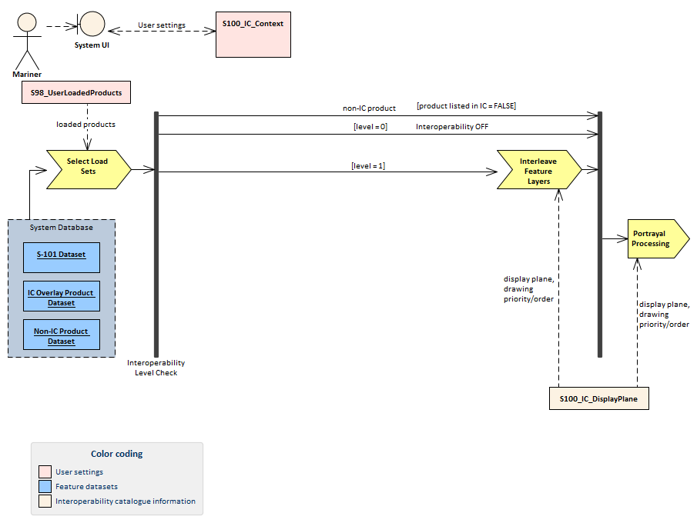

Figure A-7.1 - Interoperability processing flow (portrayal processing after interoperability)

For implementations that pass drawing instructions instead of features to interoperability processing, the flow is similar except that portrayal processing takes place before interoperability processing.

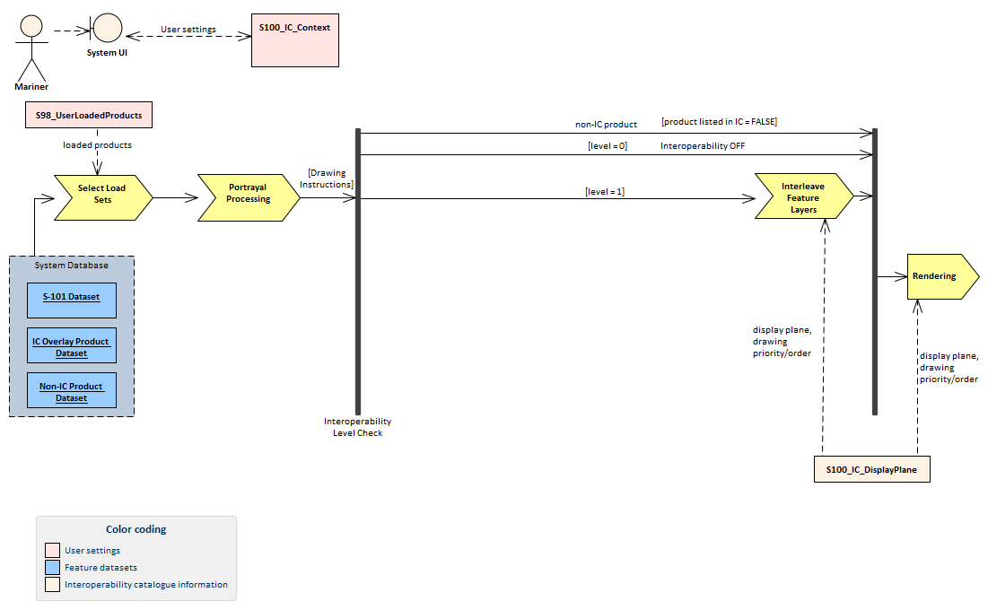

Figure A-7.2 - Interoperability processing (drawing instructions generated before interoperability processing)

Table A-7.1 - Stages in Level 1 interoperability processing

| **Stage** | **Description** | **Level** | **IC information** | **Context information** | **Remarks** |
| --- | --- | --- | --- | --- | --- |
| Select Load Sets | Select data products to be loaded | All | User adds data products to display individually | None | - |
| Portrayal Processing | Ordinary S-100 portrayal processing | All | display planes |  | Except final display processing / rendering |
| Interleave Feature Layers | Assign display plane and drawing order to feature data | 1 | S100_IC_DisplayPlane |  |  |
| Rendering | Display processing | All | S100_IC_DisplayPlane |  |  |

# Normative Implementation Guidance

There is no level-specific normative implementation guidance in this Edition of S-98. See clause 17 of the “S-98 – Main” document for implementation guidance that applies to all Levels.

# Feature Catalogue

Level 1 does not define Feature Catalogues.

# Portrayal Catalogue

Level 1 does not define Portrayal Catalogues.